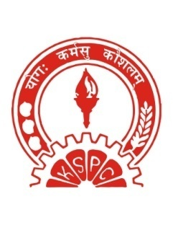
KERALA STATE PRODUCTIVITY COUNCIL
KALAMASSERY – 683 104

HOLIDAYS DURING 2016
1 | All Sundays
2 | All Second Saturdays
3 | All Fourth Saturdays
 | OTHER HOLIDAYS
1 | REPUBLIC DAY | January 26 | Tuesday
2 | SIVARATHRI | March 7 | Monday
3 | GOOD FRIDAY | March 25 | Friday
4 | VISHU | April 14 | Thursday
5 | RAMZAN | July 6 | Wednesday
6 | INDEPENDENCE DAY | August 15 | Monday
7 | BAKRID | September 12 | Monday
8 | FIRST ONAM | September 13 | Tuesday
9 | THIRU ONAM | September 14 | Wednesday
10 | THIRD ONAM | September 15 | Thursday
11 | MAHANAVAMI | October 10 | Monday
12 | VIJAYA DESAMI | October 11 | Tuesday
13 | DEEPAVALI | October 29 | Saturday

